Week 8 Direct Independent Study Progress

* **Topic Covering**: Al-Powered Phishing Detection Using NLP & Explainable Al.

# **Explainable AI Integration Continuation**

* ***Began working on a GUI that would serve as a real-world phishing detector. The idea is to train the model on the CAES-08 dataset (modify it to include more email from other sources), then use the trained model to detect likely phishing in other emails entered into the GUI, with the explainable AI being integrated.***

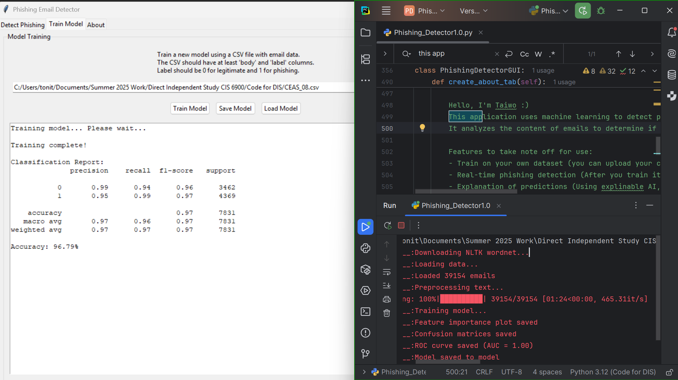

* ***The detector correctly predicts the likelihood of phishing or legit for emails similar to the test dataset I ran, but struggles with differently formatted datasets.***
* ***To address this, I plan to combine the datasets I have to one general phishing dataset, thus improving the detector.***
* ***Changing the machine learning model could also be an option to explore.***

